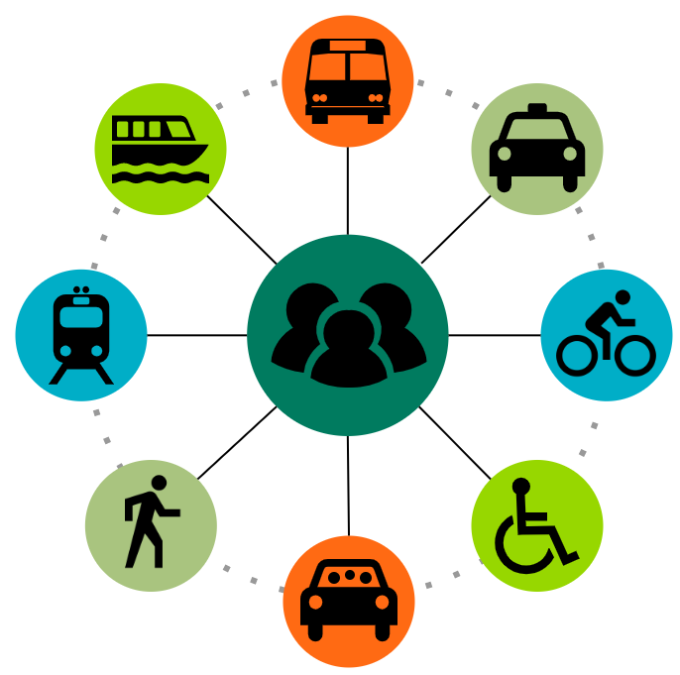
Transportation Demand Management
Executive Board

Meeting Minutes

February 22, 2023
10:00 AM – 11:55 AM
Teleconference

TDM Executive Board members
x | Dave Anderson |  | Eric Hansen |  | Charles Knutson |  | Lua Pritchard
 | Ken Casavant | x | Kirk Hovenkotter | x | David McFadden | x | Matt Ransom
x | Anthony Chen | x | Ric Illgenfritz | x | Susan Meyer | x | Melanie Truhn
x | Christine Cooley | x | Laura Johnson | x | Roger Millar |  | Laura Watson
x | Katie Garrow |  | Kent Keel |  | Chris O’Claire | x | Anna Zivarts
 | Celeste Gilman
Technical Committee members
x | Alan Adolf |  | Jennifer Hass |  | Michelle Rasmussen |  | Michael Villnave
x | Mary Anderson | x | Olivia Holden |  | Staci Sahoo |  | Dustin Watson
 | Zach Carstensen | x | Kristin Melcher |  | Heidi Speight | x | Tiff West
x | Carol Cooper | x | Karen Parkhurst | x | Kim Stolz |  | Bryce Yadon

WSDOT staff present: Bill Baumann, Steven Breaux, Sylvia Crum, Ricardo Gotla, Patrick Green,
Rebecca Jabbar, Brian Lagerberg, Christie Stelzig, Carol Thompson (consultant), Michael Wandler

Meeting convened at 10:00 AM
- Welcome and introductions – Roger Millar
  - Roger welcomed the group and introduced Chrissy Cooley to the board. She will serve as Puget Sound Clean Air Agency representative.
  - Roll call.

- Public comment – none

- State of Transportation presentation – Roger Millar
  - Roger delivered State of Transportation presentation: Maintaining a resilient transportation system in a rapidly changing world
  - Group discussion:
Katie Garrow: Thanked Roger for acknowledging compacting issues of housing and transportation. Housing costs have risen so much that home ownership is out of reach for many, even middle-class families, in the Seattle area. Appreciate the humane response to houselessness.

Anna Zivarts: Transit service and ridership levels. Telework is great but worry about future of transit systems. Reliability of service due to lack of operators is a concern. How are we thinking about the future reliability of service? Agencies are concerned, ridership is returning, but it remains below pandemic levels.

Ric Ilgenfritz: Yes, it’s a problem, but bullish on solutions. During pandemic, those most in need rose to the surface. Ridership patterns changed – but its incrementally returning. And its returning in dense corridors. Swift ridership is more than 2020 levels. The opportunity to innovate is here.

Susan Meyer: Transit is changing its definition of success. Right now, not all riders are prioritized (peak commute, etc.) Improve service to align with count of operators.

Anthony Chen: Land use and transportation connection. RTPOs are limited in their ability to address land use policy. Their power to influence land use is very constrained.

Roger: When local governments and developers make land use decisions, they are not paying the full cost. Often state – not local – transportation systems absorb the increased transportation demand associated with new development and the cost for addressing it.

Dave Andersen: What is the cost of expanding the UGA vs. tradeoffs? It’s estimated that WA will need 1M housing units to accommodate population increases. How do you create those opportunities? The question is where are going to get the road capacity for 1M housing units. Legalize housing in areas where the costs are lower? Make better use of the system that’s already been built? A free road isn’t a free lunch. It’s free puppy; you’re going to own and care for it for years to come.

- TDM projects overview – Sylvia Crum, Ricardo Gotla, Patrick Green
  - Ricardo reviewed the TDM workplan – staff are juggling multiple projects to improve and enhance CTR program and advance TDM throughout the state. Major milestones completed on or before stated deadlines, and all projects are schedule and expected to be completed by due date of September 2023.
  - Sylvia reviewed CTR budget project. Going through feedback process – many stakeholder meetings. Receiving stakeholder feedback on budget scenarios is the next step.
  - Ricardo shared the updated Mobility Partnerships Grant proposal that now includes 31 logos from organizations that wish to demonstrate support for the proposal.
Matt Ransom: RTC would like to see the program adopted by the legislature this year. CTR program doesn’t address many commute needs and this proposal gets us one step closer to more flexible TDM programing, expands the tent, and encourages innovations.

- Legislative session transportation updates – Steven Breaux,
  - Roger welcomed and thanked Steve, WSDOT’s legislative affairs director, for presenting to board.
  - WSDOT priority this year is safety. Both Senate Transportation Chair Liias and Ranking Minority Senator King just wrapped up a bipartisan vote in support of speed safety cameras in WSDOT construction sites. Needed to maintain safety of maintenance crews. Other safely bills the legislature is considering includes no right turns at red lights, lowering the blood alcohol level from 0.8%-0.5%, limiting traffic stops by law enforcement, enforcing proper use of rest areas so parking is available for truck drivers who need facilities to rest. Social justice advocates are pushing for a bill to lift restriction on jaywalking. Other priorities included the maintenance of existing capital investments, fish passage and new ferry construction funding.
  - Chair Liias is also focused on passing a transit-oriented development bill that would require greater housing density within ½ mile of major transit stops and would stand up a new grant program to support that development.
Meeting adjourned at 11:55AM

