DRAFT
CTR Law Update 2021 – Initial Report
8.18.21
Potential new commute trip reduction program emphasis areas
In its 2021-2023 session, the Legislature directed WSDOT and the Transportation Demand Management (TDM) Technical Committee to conduct an update of the Commute Trip Reduction (CTR) program (SHB 1514, Sec. 4).
After consultation with key stakeholders, WSDOT and the committee developed recommended emphasis areas for an updated CTR Program to address trends driving change in the transportation world:
- Access in economically disadvantaged areas.
Shift program focus to assuring access to multimodal options in all low-income communities and populations throughout Washington, urban and rural.
- More intensively support CTR in urban areas/peak hour commutes. Emphasize congestion mitigation in existing CTR program areas.
Expand program in existing CTR jurisdictions to include peak periods designated by the jurisdiction based on local conditions to address commute and non-commute trip types.
- Expand CTR to rapid growth areas/congestion outside traditional peak hour commutes (i.e., suburban arterials, weekend and midday congestion, Richland, ski areas). Emphasize congestion mitigation in rapid growth areas outside existing CTR program areas.
Expand program to include urban/suburban areas outside of designated affected urban growth areas that are experiencing rapid growth.
Challenge to adapt
The need for nimbleness
Transportation, like so many industries and aspects of our lives, must adapt to rapid changes in the world. Some trends driving changes in transportation have been visible for a while now:
- More widespread and intense traffic congestion.
- Climate change as indicated by wildfires, droughts and extreme weather.
- Displacement of middle- and low-income people from in-city housing markets.
- Aging population, particularly people over 80 years old.
- Ongoing and increasing economic inequity, including by race, education and rural/urban location.
- Technology advancements, including on-demand information and modes of travel; low and zero emissions vehicles; and automation.
- Surge in telework and home deliveries accelerated by the COVID-19 pandemic.
Change is always a part of life, but the pace of change has increased noticeably and does not appear to be slowing down in the foreseeable future.
To respond effectively, the transportation industry needs to become more and more nimble and use every tool available to adapt to these trends. Nimble is not a word usually associated with an infrastructure-based industry. Yet nimbleness is what the current world demands.
Practical Solutions
The Practical Solutions approach is WSDOT’s answer to the demand for nimbleness. The Practical Solutions approach and transportation system management and operations strategy emphasize preserving and making the most of existing transportation infrastructure and systems before expanding them.
The state’s CTR Program offers extensive potential to meet travel and community needs and adapt to changing conditions. The program also has the potential to support Practical Solutions, transportation systems management and operations, and state transportation policy goals. The program can provide this support in a manner that is nimble and tailored to different communities around the state.
With its current focus on commute trips at large employers, the CTR Program addresses only 4 percent of daily trips in Washington. Expansion of the program to the recommended emphasis areas would begin to capture the other 96 percent of daily trips in the state.
With its long and successful track record, the CTR Program is well positioned to adapt to the trends driving changes in transportation. The program can help advance an array of state-wide goals while carrying out the program’s original goals to reduce congestion and improve air quality by reducing commute drive-alone trips at large employers.
Purpose of the Commute Trip Reduction Program
In the CTR law (RCW 70A.15.4000-4110), the purpose of the state’s CTR Program is to improve air quality, reduce congestion and reduce gasoline consumption.
There are two major actions mandated by the CTR law to accomplish this purpose:
- To reduce vehicle miles traveled, greenhouse gas emissions and fuel consumption, require major employers to reduce the number of drive-alone commute trips at their worksite by shifting trips away from single-occupancy vehicles to other travel modes such as transit, vanpooling, carpooling, telework, biking, and walking which.
- Require local, regional and state governments to collaborate on CTR programs.
Proven results
In the 30 years since the CTR law was adopted in 1991, jurisdictions have partnered with employers and state, regional, and local agencies to implement CTR programs in affected urban growth areas. These programs largely focus on employers who have 100 or more full-time employees who commute to a worksite from 6:00-9:00 a.m. on weekdays. These programs also largely focus on enabling and incentivizing employees to ride the bus, rideshare, walk, bicycle or work from home.
The state’s CTR Program is a mature program that has proven its ability to deliver results and meet the changing needs of communities and employers. It has created and sustained community coalitions that support travel choices and transportation system efficiency.
While CTR has continued its focus on large employers over the years, it has also evolved to allow a broader reach and more flexibility to jurisdictions. Local CTR coalitions have:
- Boosted transit ridership through widespread availability of employer-sponsored transit passes.
- Created thousands of employer-supported vanpools.
- Expanded the use of compressed work schedules, flex schedules, and telework.
The state’s CTR Program has proven its effectiveness and staying power. Jurisdictions across the state have integrated their CTR programs and strategies into their comprehensive plans and visions for their communities. Washington’s CTR law is also the gold standard for CTR programs across the nation. The CTR programs of Washington’s jurisdictions continue to be in the forefront of innovation for CTR.
Of the nearly 600,000 employees working at CTR-affected worksites from 2019 to 2020, 50.7 percent choose alternatives to driving alone for their commute to and from work. This is 76 percent higher than the state average (28.8), and 115 percent higher than the national average (23.6).
Washington commuters non-drive-alone trip rate
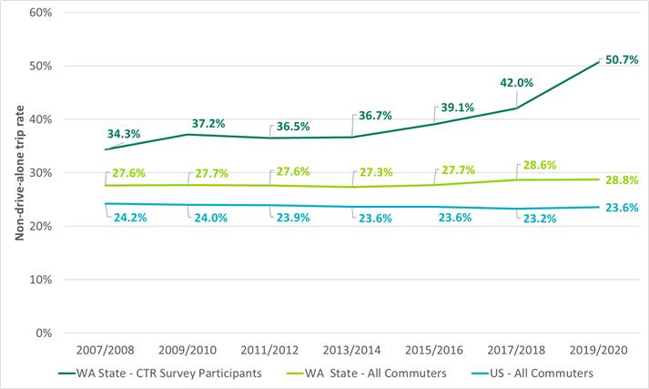
Next steps
Over the coming year, the TDM Technical Committee will take steps to shift the CTR program emphasis areas:
- Fall/winter 2021 – Develop and submit a full report on an update to the CTR Program to the Legislature. The report will detail CTR program history and requirements, governance practices, and relevant social and economic trends.
Summer 2022 – Engage the Legislature and other stakeholders to develop consensus on future CTR Program emphasis areas.
Winter 2022 – Develop and submit Legislation to House Transportation Committee that supports updated CTR Program emphasis areas.

Performance data were influenced by two unusual circumstances related to Covid-19. First, there was a significant increase in telework for the sites that surveyed after March 2020. Second, almost 200 fewer worksites surveyed in 2019-20 than in 2017-18. These sites have historically had VMT results above the current cycle’s statewide average. It is likely that part of the improvement in the numbers is due to those sites not surveying. While the gains from telework are sustainable, the next cycle that has all CTR-affected worksites survey will likely have results that fall between the numbers from 2017-18 and the numbers from 2019-20.

