Policy change to the 2021-22 CTR survey cycle and surveying effort
WSDOT is proposing the following policy change to the 2021-22 CTR survey cycle:
Synchronize the upcoming CTR survey cycle with the next CTR grantee contracts period by having the 2021-22 CTR survey cycle start on July 1, 2021 (instead of January 1, 2021) and run through June 30, 2023 (instead of December 31, 2022). Surveying for the 2021-22 cycle will being in fall 2021 (instead of spring 2021) and use the new CTR survey system (which should be operational at that time).

Visual representation of these changes:
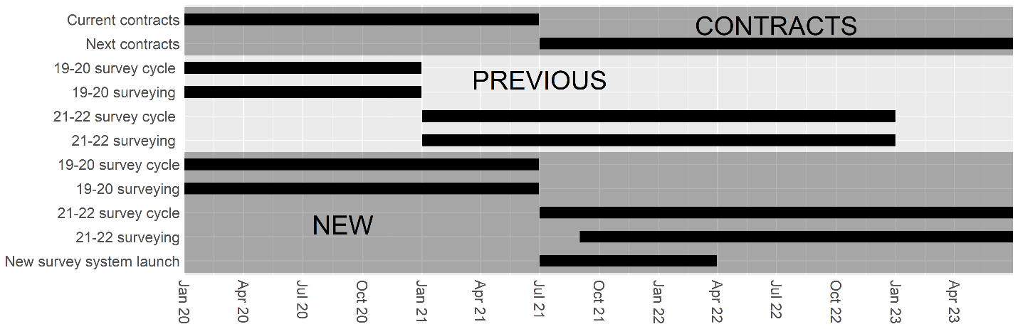

WSDOT is seeking approval by the TDM technical committee on September 24, 2020.

