Changes to the 2021-22 CTR survey cycle frequently asked questions (FAQs)
What is changing?
- WSDOT is synchronizing the upcoming CTR survey cycle with the next CTR grantee contracts period by having the 2021-22 CTR survey cycle start on July 1, 2021 (instead of January 1, 2021) and run through June 30, 2023 (instead of December 31, 2022).
- Accordingly, jurisdictions will start surveying for the 2021-22 cycle in fall 2021 (instead of spring 2021) and use the new CTR survey system.
Visual representation of these changes:
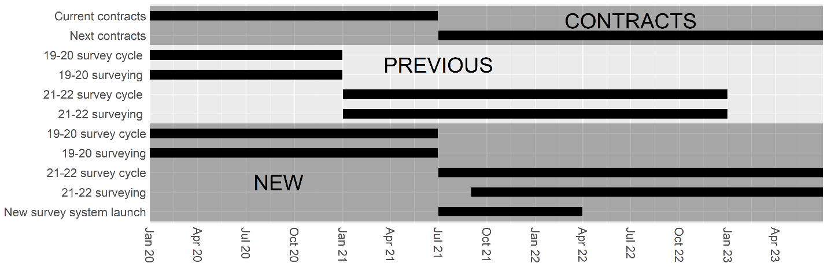

What are the benefits of these changes?
There are three main benefits:
- First, the CTR grantee contracts and the survey cycles would be synchronized. Currently, the CTR grantee contracts are based on the fiscal biennium, running from July 1st of odd years through June 30th of the next odd year (e.g., 7/1/2019 through 6/30/2021). The CTR survey cycle is based on the calendar year; therefore, the beginning of the survey cycles and CTR contracts are separated by six months. By delaying the start of the next survey cycle until 7/1/2021, and having it run through 6/30/2023, the survey cycles and CTR contracts will finally be synchronized, allowing work plans to fully correspond to their respective surveying efforts.
- Second, this will limit inconsistencies in the data we collect during the cycle. As both the CTR surveying system and the survey questions are getting refreshed, it would cause continuity issues to collect data using the old platform during the spring of 2021 and then move to the new platform in the fall of 2021. The data from the different periods would not be directly comparable, as mode types, distance calculations, and attitudinal questions will be updated with the new system. Therefore, it is beneficial to delay the new cycle until the surveying instrument is ready.
- Third, this will allow us to introduce more flexibility to deal with disruptions from the pandemic in our current survey cycle (i.e., 2019-20). Specifically, we will extend the current CTR survey cycle to run through June 30, 2021, as opposed to ending it on December 31, 2020. This allows jurisdictions the option to delay their fall 2020 surveys until spring 2021, when things are (hopefully) closer to normal.
What does this mean for surveying during spring of 2021?
- CTR jurisdictions can use spring of 2021 to conclude any outstanding surveys from the 2019-20 survey cycle. Any sites that needed to survey or resurvey (e.g., sites that did not meet response rate requirements) for the 2019-20 survey cycle but that were not able to because of the pandemic (which discontinued surveying since spring of 2020) can be surveyed in the spring of 2021 and count towards the 2019-20 cycle’s numbers. This includes all of the Boeing sites.
- No sites can be surveyed for 2021-22, however. If a site has already successfully surveyed for 2019-20 and surveys again in spring 2021, the new data will overwrite their previous 2019-20 cycle results. That is, the survey will not count towards 2021-22 survey cycle requirements.
- WSDOT will provide a survey alternative, but it will be optional and not count towards jurisdictional goals. If jurisdictions want to survey their sites without it counting towards the actual survey requirements, they are welcome to use the supplemental survey. This questionnaire is in SurveyMonkey and includes questions that allow us to calculate VMT (vehicle miles traveled), NDAT (non-drive-alone travel rate), and mode splits – the same information that goes into the CTR program report (formerly called the aggregate report). The supplemental survey also has questions related to telework that should be beneficial to employers determining what their offices will look like after the pandemic. Please contact Kate Ito (kate.ito@wsdot.wa.gov) for more information.

What are the additional concerns about this change?
- What if cities have an ordinance or other requirement for sites to survey? Many requirements have gone unenforced during the pandemic. Given the devastation that COVID has caused, we hope our partners will focus on the spirit of the law (e.g., working with employers to improve their CTR programs) over the letter of the law. We also reached out to our jurisdictional partners to hear their thoughts and did not hear any concerns.
- Does this plan conflict with RCW requirements? No. The RCW only requires sites to survey every other year. This means it will actually be easier to meet that requirement for the 2019-20 survey cycle, and there will still be plenty of time to meet the requirement for the 2021-22 survey cycle once the new system is operational.
- Will we still be able to report to the legislature on time? Yes. The deadline for the report on the 2019-20 CTR survey cycle is December 1, 2021, with draft information required by September 2021. This will give WSDOT over two months to finalize the numbers after the survey cycle concludes on June 30, 2020; the work itself should take less than a week.
- Who authorized this change? The TDM Technical Committee [is expected to] authorize[d] this change to the 2021-22 CTR survey cycle at their September 24, 2020 meeting [by a unanimous vote].

